Implementing Common Alert Protocol (CAP) Alerts in IoT

CAP Alerts
We can leverage IoT CS’s logical interface concept to process CAP alerts for, for example, Location Maps.

Set Up Steps
Steps include creation of a ‘device’ type, a ‘device’ instance, an event type an event definition, a physical interface, a logical interface and mappings between the event and logical interface. The final step validates and activates the configuration.
A node-red flow automating these steps is described here.

Create Device type
POST https://{{{orgId}}}.internetofthings.ibmcloud.com/api/v0002/device/types
id: CapAlertSender
description: Device for transmitting/receiving CAP alerts

Create device instance
POST https://{{{orgId}}}.internetofthings.ibmcloud.com/api/v0002/device/types/{{{deviceType}}}/devices
deviceId: capAlertSender
authToken: Pa88w0rd

Define Event schema for Common Alerting Protocol alert
IoT mandates that the payload for events is wrapped inside an object with name ‘d’. A valid schema looks as below. Note that TIMESTAMP/DATE fields must be defined as strings here (see logical interface schema later).
{
"$schema": "http://json-schema.org/draft-04/schema#",
"type" : "object",
"title" : "capAlertSchem",
"description" : "JSON Schema that defines the CAP alert structure",
"properties" : {
"d" : {
"description": "Data container",
"type": "object",
"properties": {
"area" : {
"description" : "Name of Area associated with Alert",
"type" : "string",
"default": ""
},
"areaDes" : {
"description" : "Alert area description",
"type" : "string",
"default": ""
},
"event" : {
"description" : "Description of Alert",
"type" : "string",
"default": ""
},
"location" : {
"description" : "Alert location",
"type" : "string",
"default": ""
},
"headline" : {
"description" : "Alert headline",
"type" : "string",
"default": ""
},
"addresses" : {
"description" : "Alert address(es)",
"type" : "string",
"default": ""
},
"severity" : {
"description" : "Severity of Alert (Extreme, Severe, Moderate, Minor, Unknown)",
"type" : "string",
"default" : "Unknown"
},
"sender" : {
"description" : "Name of the Sender of the Alert",
"type" : "string",
"default": ""
},
"startdate" : {
"description" : "Time of Alert",
"type" : "string",
"default": ""
},
"enddate" : {
"description" : "Alert end time",
"type" : "string",
"default": ""
},
"lastupdate" : {
"description" : "Last update time of Alert ",
"type" : "string",
"default": ""
},
"onset" : {
"description" : "Onset of alert",
"type" : "string",
"default": ""
},
"expires" : {
"description" : "Expiration of Alert",
"type" : "string",
"default": ""
},
"msgType" : {
"description" : "Alert type (Alert, Update, Cancel, Ack, Error)",
"type" : "string",
"default" : "Alert"
},
"urgency" : {
"description" : "Alert urgency (Immediate, Expected, Future, Past, Unknown)",
"type" : "string",
"default" : "Unknown"
},
"category" : {
"description" : "Alert Category (Geo, Met, Safety, Security, Rescue, Fire, Health, Env, Transport, Infra, Other)",
"type" : "string",
"default" : "Other"
},
"certainty" : {
"description" : "Alert Certainty (Observed, Likely, Possible, Unlikely, Unknown)",
"type" : "string",
"default" : "Unknown"
},
"code" : {
"description" : "Alert code",
"type" : "string",
"default": ""
},
"contact" : {
"description" : "Alert contact",
"type" : "string",
"default": ""
},
"description" : {
"description" : "Alert description",
"type" : "string",
"default": ""
},
"effective" : {
"description" : "Effective date of Alert",
"type" : "string",
"default": ""
},
"eventCode" : {
"description" : "Alert event code",
"type" : "string",
"default": ""
},
"geocode" : {
"description" : "Alert geocode",
"type" : "string",
"default": ""
},
"identifier" : {
"description" : "Alert identifier",
"type" : "string",
"default": ""
},
"incidents" : {
"description" : "Alert incidents",
"type" : "string",
"default": ""
},
"instruction" : {
"description" : "Alert instruction",
"type" : "string",
"default": ""
},
"note" : {
"description" : "Alert note",
"type" : "string",
"default": ""
},
"parameters" : {
"description" : "Alert parameters",
"type" : "string",
"default": ""
},
"references" : {
"description" : "Alert references",
"type" : "string",
"default": ""
},
"resource" : {
"description" : "Alert resource",
"type" : "string",
"default": ""
},
"restriction" : {
"description" : "Alert restriction",
"type" : "string",
"default": ""
},
"scope" : {
"description" : "Alert scope",
"type" : "string",
"default": ""
},
"senderName" : {
"description" : "Alert sender's name",
"type" : "string",
"default": ""
},
"sent" : {
"description" : "Alert sent date",
"type" : "string",
"default": ""
},
"source" : {
"description" : "Alert source",
"type" : "string",
"default": ""
},
"web" : {
"description" : "Alert web reference",
"type" : "string",
"default": ""
},
"status" : {
"description" : "Status of the Alert",
"type" : "string",
"default": ""
}
},
"required" : [
"event",
"certainty",
"msgType",
"severity",
"sender",
"urgency",
"category",
"location",
"references"
]
}
},
"required" : [
"d"
]
}

Add the draft Event Type Schema to the System
POST https://{{{orgId}}}.internetofthings.ibmcloud.com/api/v0002/draft/schemas
name: CapAlertSchema
schemaFile: CapAlertSchema.json

Create draft Event Type using schema
POST https://{{{orgId}}}.internetofthings.ibmcloud.com/api/v0002/draft/event/types
Name: CapAlert
schemaId: 5c1422b6acf90e002b469554 (id returned from schema draft step)

Create Physical Interface
POST https://{{{orgId}}}.internetofthings.ibmcloud.com/api/v0002/draft/physicalinterfaces
name: CAP Alert Sender Physical Interface

Add the event type to the physical interface
POST https://{{{orgId}}}.internetofthings.ibmcloud.com/api/v0002/draft/physicalinterfaces/{{{physicalInterfaceId}}}/events
eventId: capAlert
eventTypeId: 5c1422b766914d002b207ba6 (id returned from event type creation)

Connect the device type to the physical interface
POST https://{{{orgId}}}.internetofthings.ibmcloud.com/api/v0002/draft/device/types/{{{deviceType}}}/physicalinterface
id: 5c1422b7acf90e002b469555 (id returned from physical interface creation)

Create a Schema for the Logical Interface
This defines the schema of the DB2 table that IoT generates (with name ‘IOT_DEVICETYPENAME’) automatically. Integers and floats are defined using the type ‘number’ (defines with DOUBLE data type in DB2). TIMESTAMP properties must be specified as Strings with format ‘date-time’ (see here). One ‘gotcha’ is that date-time fields will cause a json validation error if they are left blank (even if they are not defined as required). You can, for example, use the jsonata ‘$now()’ function to generate a valid TIMESTAMP value if the incoming event field is blank ("startdate": "$event.d.startdate?$event.d.startdate:$now()").
{
"$schema": "http://json-schema.org/draft-04/schema#",
"type" : "object",
"title" : "capAlertLogicalInterfaceSchema_V4",
"description" : "JSON Schema that defines the CAP alert logical interface structure V4",
"properties" : {
"area" : {
"description" : "Name of Area associated with Alert",
"type" : "string",
"default": ""
},
"areaDes" : {
"description" : "Alert area description",
"type" : "string",
"default": ""
},
"event" : {
"description" : "Description of Alert",
"type" : "string",
"default": ""
},
"location" : {
"description" : "Alert location",
"type" : "string",
"default": ""
},
"headline" : {
"description" : "Alert headline",
"type" : "string",
"default": ""
},
"addresses" : {
"description" : "Alert address(es)",
"type" : "string",
"default": ""
},
"severity" : {
"description" : "Severity of Alert (Extreme, Severe, Moderate, Minor, Unknown)",
"type" : "string",
"default" : "Unknown"
},
"sender" : {
"description" : "Name of the Sender of the Alert",
"type" : "string",
"default": ""
},
"startdate" : {
"description" : "Time of Alert",
"type" : "string",
"format":"date-time",
"default": ""
},
"enddate" : {
"description" : "Alert end time",
"type" : "string",
"format":"date-time",
"default": ""
},
"lastupdate" : {
"description" : "Last update time of Alert ",
"type" : "string",
"format":"date-time",
"default": ""
},
"onset" : {
"description" : "Onset of alert",
"type" : "string",
"format":"date-time",
"default": ""
},
"expires" : {
"description" : "Expiration of Alert",
"type" : "string",
"format":"date-time",
"default": ""
},
"msgType" : {
"description" : "Alert type (Alert, Update, Cancel, Ack, Error)",
"type" : "string",
"default" : "Alert"
},
"urgency" : {
"description" : "Alert urgency (Immediate, Expected, Future, Past, Unknown)",
"type" : "string",
"default" : "Unknown"
},
"category" : {
"description" : "Alert Category (Geo, Met, Safety, Security, Rescue, Fire, Health, Env, Transport, Infra, Other)",
"type" : "string",
"default" : "Other"
},
"certainty" : {
"description" : "Alert Certainty (Observed, Likely, Possible, Unlikely, Unknown)",
"type" : "string",
"default" : "Unknown"
},
"code" : {
"description" : "Alert code",
"type" : "string",
"default": ""
},
"contact" : {
"description" : "Alert contact",
"type" : "string",
"default": ""
},
"description" : {
"description" : "Alert description",
"type" : "string",
"default": ""
},
"effective" : {
"description" : "Effective date of Alert",
"type" : "string",
"format":"date-time",
"default": ""
},
"eventCode" : {
"description" : "Alert event code",
"type" : "string",
"default": ""
},
"geocode" : {
"description" : "Alert geocode",
"type" : "string",
"default": ""
},
"identifier" : {
"description" : "Alert identifier",
"type" : "string",
"default": ""
},
"incidents" : {
"description" : "Alert incidents",
"type" : "string",
"default": ""
},
"instruction" : {
"description" : "Alert instruction",
"type" : "string",
"default": ""
},
"note" : {
"description" : "Alert note",
"type" : "string",
"default": ""
},
"parameters" : {
"description" : "Alert parameters",
"type" : "string",
"default": ""
},
"references" : {
"description" : "Alert references",
"type" : "string",
"default": ""
},
"resource" : {
"description" : "Alert resource",
"type" : "string",
"default": ""
},
"restriction" : {
"description" : "Alert restriction",
"type" : "string",
"default": ""
},
"scope" : {
"description" : "Alert scope",
"type" : "string",
"default": ""
},
"senderName" : {
"description" : "Alert sender's name",
"type" : "string",
"default": ""
},
"sent" : {
"description" : "Alert sent date",
"type" : "string",
"format":"date-time",
"default": ""
},
"source" : {
"description" : "Alert source",
"type" : "string",
"default": ""
},
"web" : {
"description" : "Alert web reference",
"type" : "string",
"default": ""
},
"status" : {
"description" : "Status of the Alert",
"type" : "string",
"default": ""
}
},
"required" : [
"event",
"certainty",
"msgType",
"severity",
"sender",
"urgency",
"category",
"location",
"references"
]
}

Add the Draft Logical Interface Schema to the System
POST https://{{{orgId}}}.internetofthings.ibmcloud.com/api/v0002/draft/schemas
Name: CapAlertSchema_LI
schemaFile: CapAlertSchema_LI.json

Create Logical Interface using the Schema
POST https://{{{orgId}}}.internetofthings.ibmcloud.com/api/v0002/draft/logicalinterfaces
name: CAP Alert Sender Logical Interface
alias: ICapAlertSender
schemaId: 5c1422b966914d002b207ba7 (id returned from schema creation)

Add Logical interface to Device Type
POST https://{{{orgId}}}.internetofthings.ibmcloud.com/api/v0002/draft/device/types/{{{deviceType}}}/logicalinterfaces
id: 5c1422baacf90e002b469557 (id returned from logical interface creation step)

Define mappings between event and logical interfaces
As mentioned above, date-time fields can’t be left blank, so we use the jsonata $now() function to fill in blanks.
POST https://{{{orgId}}}.internetofthings.ibmcloud.com/api/v0002/draft/device/types/{{{deviceType}}}/mappings
logicalInterfaceId: 5c1422baacf90e002b469557
notificationStrategy: on-every-event
propertyMappings: {
"capAlert" : {
"note": "$event.d.note?$event.d.note:''",
"addresses": "$event.d.addresses?$event.d.addresses:''",
"expires": "$event.d.expires?$event.d.expires:$now()",
"msgType": "$event.d.msgType?$event.d.msgType:''",
"code": "$event.d.code?$event.d.code:''",
"areaDes": "$event.d.areaDes?$event.d.areaDes:''",
"references": "$event.d.references?$event.d.references:''",
"description": "$event.d.description?$event.d.description:''",
"source": "$event.d.source?$event.d.source:''",
"startdate": "$event.d.startdate?$event.d.startdate:$now()",
"effective": "$event.d.effective?$event.d.effective:$now()",
"senderName": "$event.d.senderName?$event.d.senderName:''",
"urgency": "$event.d.urgency?$event.d.urgency:''",
"web": "$event.d.web?$event.d.web:''",
"contact": "$event.d.contact?$event.d.contact:''",
"scope": "$event.d.scope?$event.d.scope:''",
"incidents": "$event.d.incidents?$event.d.incidents:''",
"event": "$event.d.event?$event.d.event:''",
"headline": "$event.d.headline?$event.d.headline:''",
"area": "$event.d.area?$event.d.area:''",
"severity": "$event.d.severity?$event.d.severity:''",
"identifier": "$event.d.identifier?$event.d.identifier:''",
"resource": "$event.d.resource?$event.d.resource:''",
"certainty": "$event.d.certainty?$event.d.certainty:''",
"onset": "$event.d.onset?$event.d.onset:$now()",
"sent": "$event.d.sent?$event.d.sent:$now()",
"eventCode": "$event.d.eventCode?$event.d.eventCode:''",
"enddate": "$event.d.enddate?$event.d.enddate:$now()",
"sender": "$event.d.sender?$event.d.sender:''",
"instruction": "$event.d.instruction?$event.d.instruction:''",
"geocode": "$event.d.geocode?$event.d.geocode:''",
"restriction": "$event.d.restriction?$event.d.restriction:''",
"location": "$event.d.location?$event.d.location:''",
"lastupdate": "$event.d.lastupdate?$event.d.lastupdate:$now()",
"category": "$event.d.category?$event.d.category:''",
"parameters": "$event.d.parameters?$event.d.parameters:''",
"status": "$event.d.status?$event.d.status:''" }
}

Validate and Activate Configuration
PATCH https://{{{orgId}}}.internetofthings.ibmcloud.com/api/v0002/draft/device/types/{{{deviceType}}}
operation: validate-configuration
PATCH https://{{{orgId}}}.internetofthings.ibmcloud.com/api/v0002/draft/device/types/{{{deviceType}}}
operation: activate-configuration

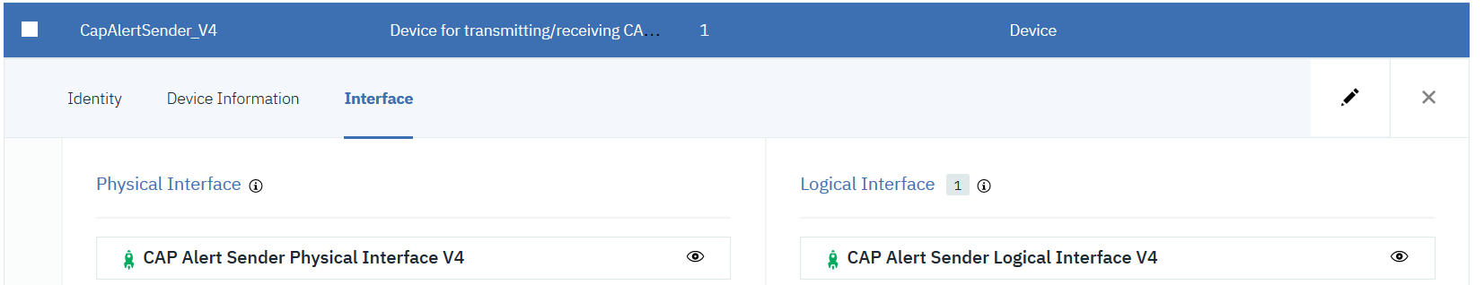

Publishing an Event to IoT

http protocol

To post an event for a ‘device’ to IoT’s message hub using the http protocol the url pattern is:
https://{orgid}.messaging.internetofthings.ibmcloud.com:8883/api/v0002/device/types/{deviceType}/devices/{deviceId}/events/{eventId}

Basic Authentication is used, with user ‘use-token-auth’ and password the password defined for the device. For example:

POST: https://9kpzic.messaging.internetofthings.ibmcloud.com:8883/api/v0002/device/types/CapAlertSender/devices/capAlertSender/events/capAlert

mqtt protocol

To post using the mqtt protocol the url is:

9kpzic.messaging.internetofthings.ibmcloud.com:8883

The Client ID must follow the pattern:

d:orgId:deviceTypeId:deviceId

For example:

d:9kpzic:CapAlertSender:capAlertSender

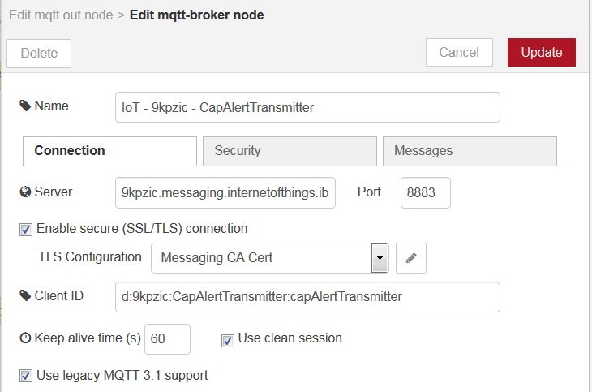

The topic of the message is in the form:

iot-2/evt/{{{eventId}}}/fmt/json

e.g.:

iot-2/evt/capEvent/fmt/json

Payload (json) for the event must be wrapped in a ‘d’ object as shown in the sample below:

{
"d":{
"event":"Smoking violation",
"msgType":"Alert",
"urgency":"Future",
"status":"Complete",
"sender":"John",
"headline":"Violation",
"certainty":"Observed",
"enddate":"2018-11-02T19:06:00Z",
"startdate":"2018-11-02T19:05:00Z",
"area":"Gate C",
"references":"",
"category":"Health",
"location":"POINT(-93.1965780 44.9842060)",
"severity":"Moderate"
}
}

IoT subscribes to topics conforming to the pattern below:

iot-2/type/{deviceType}/id/{deviceId}/evt/{eventId}/fmt/json

Actions currently performed by IoT include:

Load the raw data to a Cloudant database
By default the data is stored in a daily ‘bucket’ with name in the format: iotp_orgid_default_yyyy-mm-dd
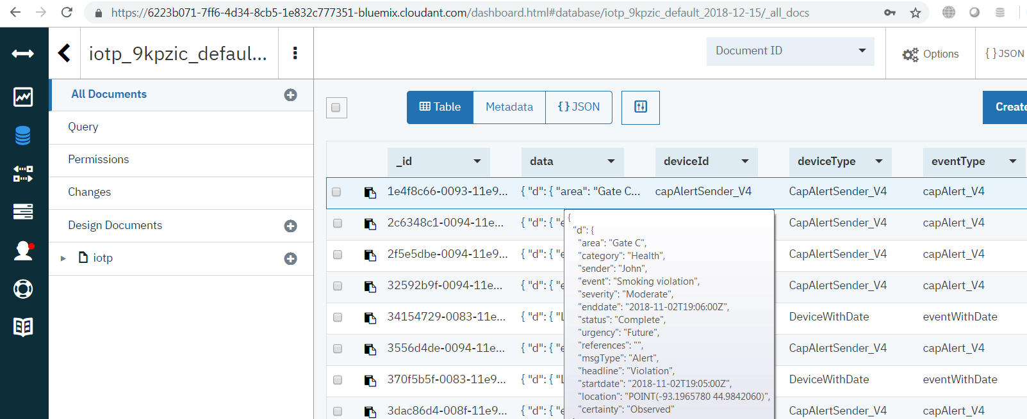

Data is retained by default in Cloudant storage for 1 month. An _id value is generated for each record. Periodically, the raw Cloudant data is copied to Object Storage, where it is retained for 1 year by default.

Update the state of the device based on the data
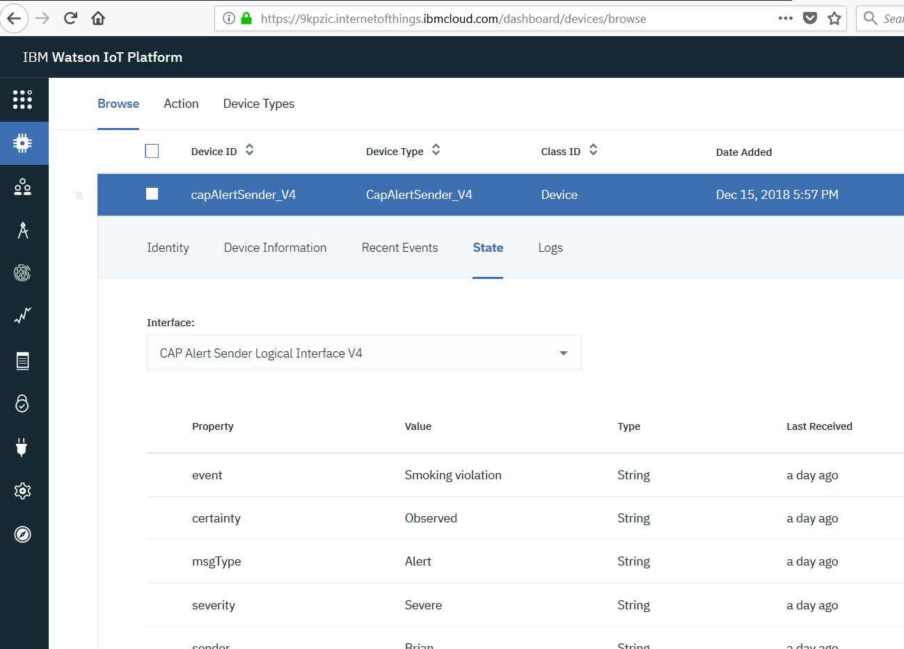

Apply any rules associated with the device type’s logical interface.
If a rule evaluates to true a message is published to the topic ‘iot-2/intf/<logicalInterfaceId>/rule/<ruleId>/evt/trigger’.

Load transformed Data into DB2
A table is automatically created by IoT based on the Logical Interface definition (with table name based on the device type, ‘IOT_DEVICETYPENAME’)
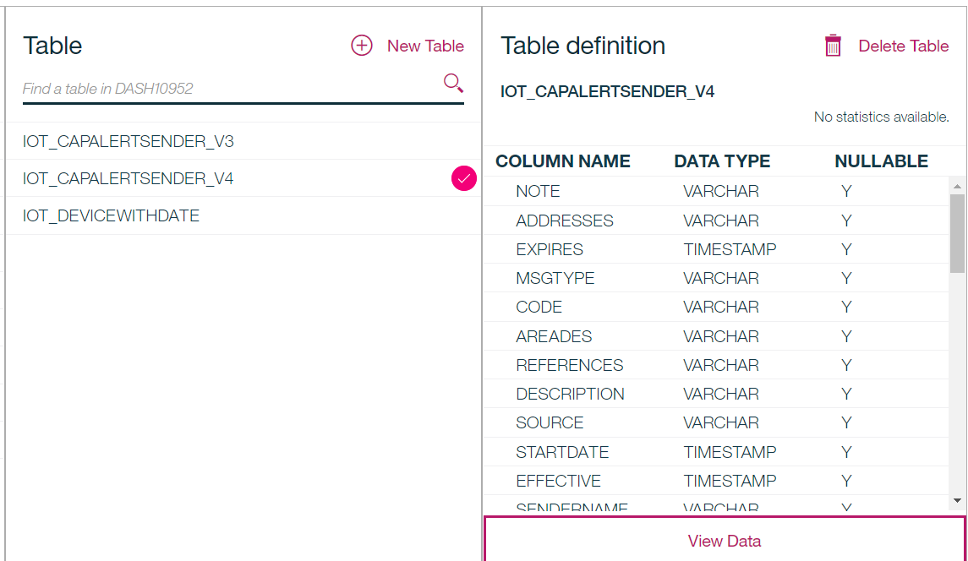

CREATE TABLE "DASH10952"."IOT_CAPALERTSENDER_V4" (
"NOTE" VARCHAR(1024),
"ADDRESSES" VARCHAR(1024),
"EXPIRES" TIMESTAMP,
"MSGTYPE" VARCHAR(1024),
"CODE" VARCHAR(1024),
"AREADES" VARCHAR(1024),
"REFERENCES" VARCHAR(1024),
"DESCRIPTION" VARCHAR(1024),
"SOURCE" VARCHAR(1024),
"STARTDATE" TIMESTAMP,
"EFFECTIVE" TIMESTAMP,
"SENDERNAME" VARCHAR(1024),
"URGENCY" VARCHAR(1024),
"WEB" VARCHAR(1024),
"CONTACT" VARCHAR(1024),
"SCOPE" VARCHAR(1024),
"INCIDENTS" VARCHAR(1024),
"EVENT" VARCHAR(1024),
"HEADLINE" VARCHAR(1024),
"AREA" VARCHAR(1024),
"SEVERITY" VARCHAR(1024),
"IDENTIFIER" VARCHAR(1024),
"RESOURCE" VARCHAR(1024),
"CERTAINTY" VARCHAR(1024),
"ONSET" TIMESTAMP,
"SENT" TIMESTAMP,
"EVENTCODE" VARCHAR(1024),
"ENDDATE" TIMESTAMP,
"SENDER" VARCHAR(1024),
"INSTRUCTION" VARCHAR(1024),
"GEOCODE" VARCHAR(1024),
"RESTRICTION" VARCHAR(1024),
"LOCATION" VARCHAR(1024),
"LASTUPDATE" TIMESTAMP,
"CATEGORY" VARCHAR(1024),
"PARAMETERS" VARCHAR(1024),
"STATUS" VARCHAR(1024),
"DEVICETYPE" VARCHAR(64) NOT NULL,
"DEVICEID" VARCHAR(256) NOT NULL,
"LOGICALINTERFACE_ID" VARCHAR(64) NOT NULL,
"EVENTTYPE" VARCHAR(64),
"FORMAT" VARCHAR(32) NOT NULL,
"RCV_TIMESTAMP_UTC" TIMESTAMP NOT NULL,
"UPDATED_UTC" TIMESTAMP NOT NULL
)
DATA CAPTURE NONE
COMPRESS YES;

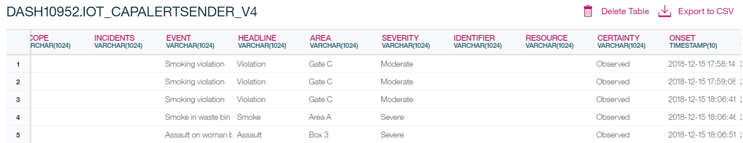

Update Analytic tables for any derived metrics configured
Derived metrics can be generated by aggregating selected data over days/weeks/months/etc
